## Metaphor/Architecture Specification Template

|  |  |  |  |
| --- | --- | --- | --- |
| Student | Diego Andres Montealegre Garcia | Date | 04/03/2015 |
| Program | Psp2.1 | Program # | 6 |
| Instructor | Luis Daniel Benavides | Language | Java |

|  |  |
| --- | --- |
| **Design** | El diseño está basado en el patrón de diseño MVC. |
| **References** |  |
|  |  |
|  |  |
|  |  |

**Graphical representation of the metaphor**

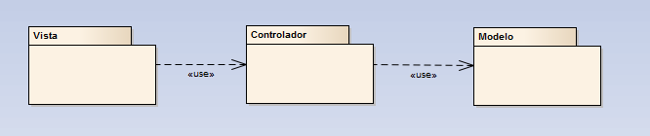

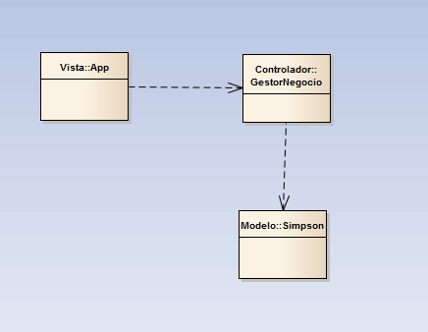

# Estructura

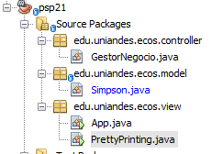

**Textual representation of metaphor**

El programa constará de tres paquetes principales: ***model, view y controller***. En el

1. ***model*** se encuentran todos los modelos con sus respectivas funcionalidades.
2. ***controller*** se encarga de procesar los eventos solicitados desde el ***view,*** es el gestor del negocio de la aplicación.
3. ***view***, invoca al gestror del negocio para mostrar los resultados
   1. la vista es la encargada de procesar los eventos solicitados por el usuario final y enviárselos al controlador.
   2. **Metaphor/Architecture Specification Template Instructions**

|  |  |
| --- | --- |
| **Purpose** | To contain the metaphor for a program, component, or system  To enable precise, rapid and complete design understanding  To facilitate thorough design and implementation reviews and inspections |
| **General** | Use this template to document the program’s high-level metaphor.  The metaphor could be based in common programming patterns as MVC, or architectural styles as tree layer design, client-server, or inversion of control frameworks  After implementation and testing, update the template to reflect the actual implemented product.  Use plain language and avoid using programming instructions wherever practical. |
| **Header** | Enter your name and the date.  Enter the program name and number.  Enter the instructor’s name and the programming language you are using. |
| **Design References** | List the references used to produce the program’s logical design.  the Operational, Functional, and State templates  the program’s requirements  any other pertinent source |
| **Graphical representation of the metaphor/Architecture** | Create a graphical representation of the main program parts and its interactions  Use clear names for each part  Use edges with arrows to show interactions  Use descriptive names for the interactions |
| **Textual representation of metaphor** | Use text to describe the main idea and metaphor used in your design  Describe the graphical representation using common language |